101100019 FROM BASE 2 TO 8:

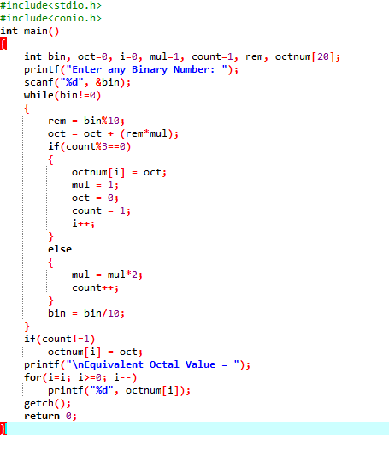

OUTPUT:

